SQL ASSIGNMENT - 7
Using Sub queries to Solve Queries

- Display EMPNO, ENAME, DEPTNO of employees who work with SCOTT (Nested Subquery)
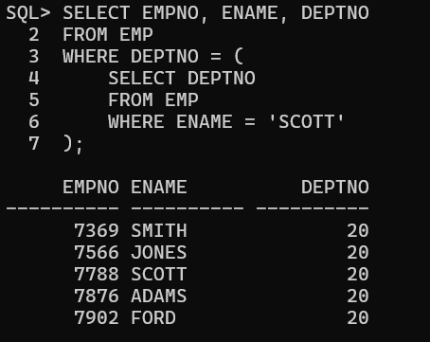

- Display employees who earn more than the average salary of EMP table
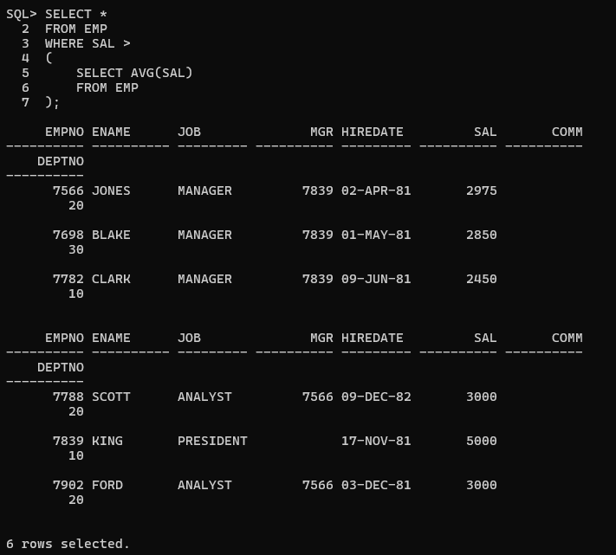

- Display ENAME, JOB who are Managers (Using EXISTS)

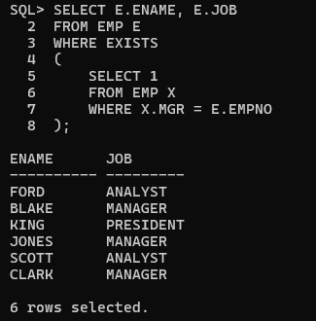

4.Display employees who earn less than the least salary of DEPTNO 10 (Using ALL)



5.Display employees who have the same DEPTNO and MGR as SCOTT, excluding SCOTT
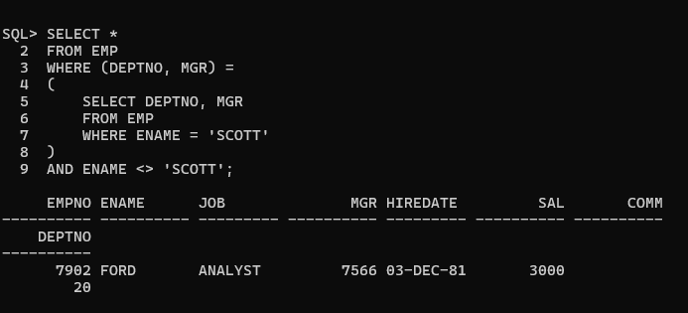

6.Display EMPNO and ENAME of employees who work in a department with any employee whose name contains 'R'
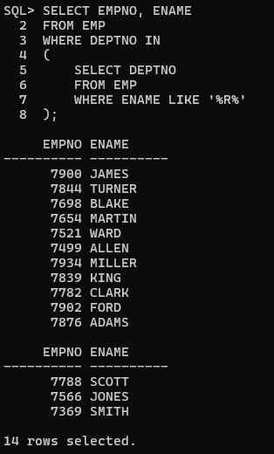

- Display ENAME, DEPTNO, JOB of employees who work in NEW YORK
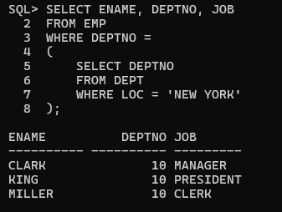

8.Prompt the user for LOC
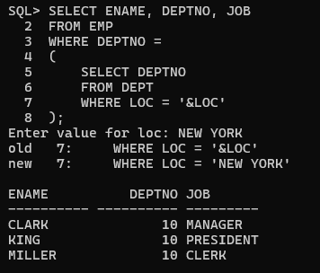

9.Display name and salary of employees who report to KING

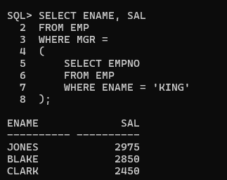

10.Display all employees working with JAMES

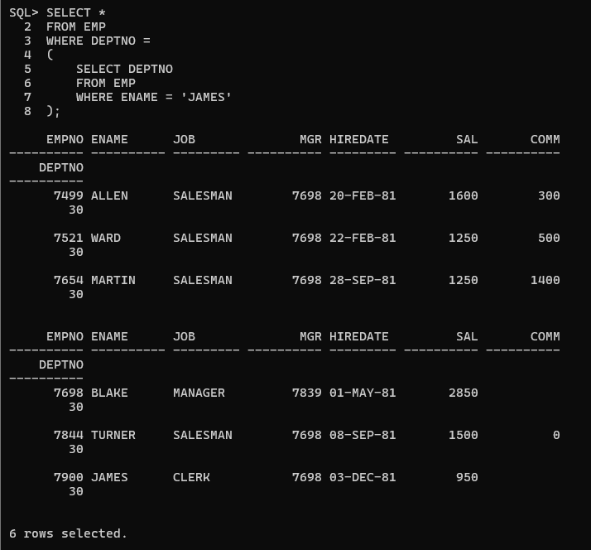

11.Display employees who earn less than the average salary of their department (Correlated Subquery)
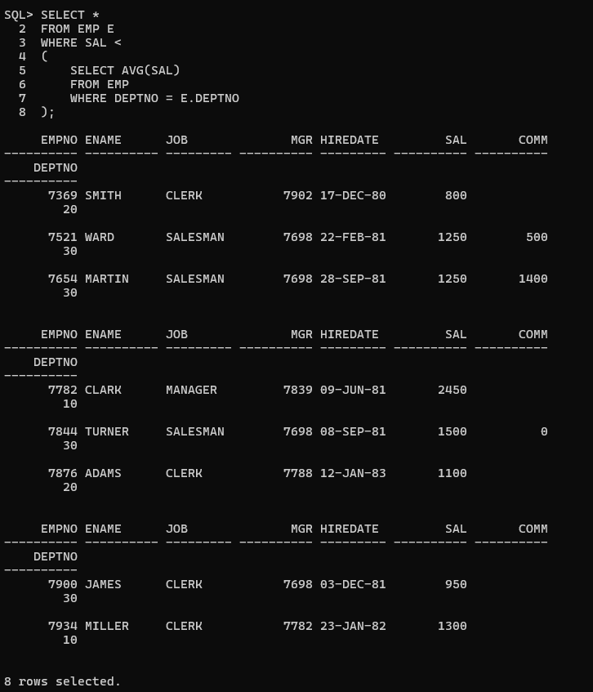
12.Display LOC and average salary of each location (Scalar Subquery)

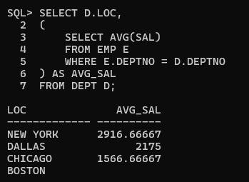

13.Display the least N salaries (Inline View)

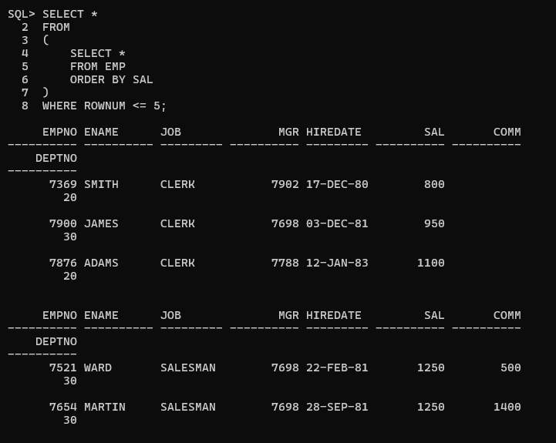

14.Display the last N rows from EMP (Correlated Subquery)

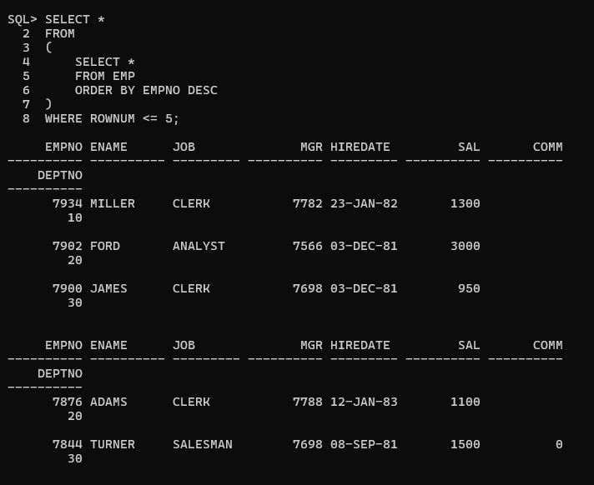

- Display employees and sort only employees working in DALLAS (Scalar Subquery)
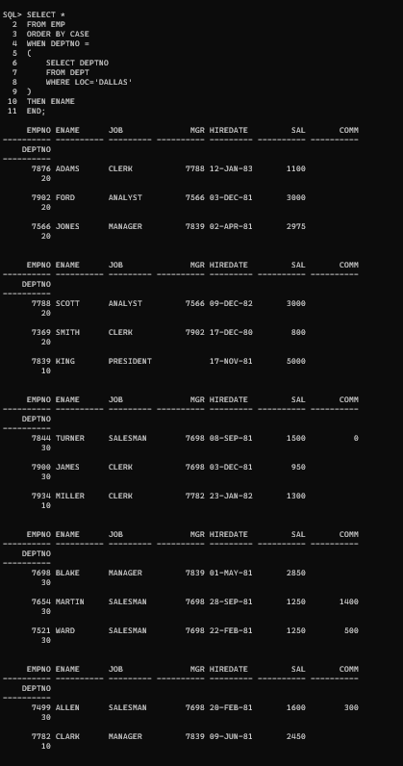

- Display employees whose salary is less than the department average and also display the average salary (Inline View)
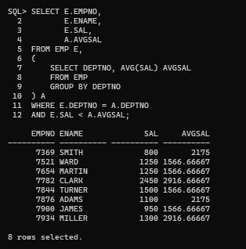

17.Display the LOC of departments whose total salary is less than the average salary of all employees (WITH Clause)
